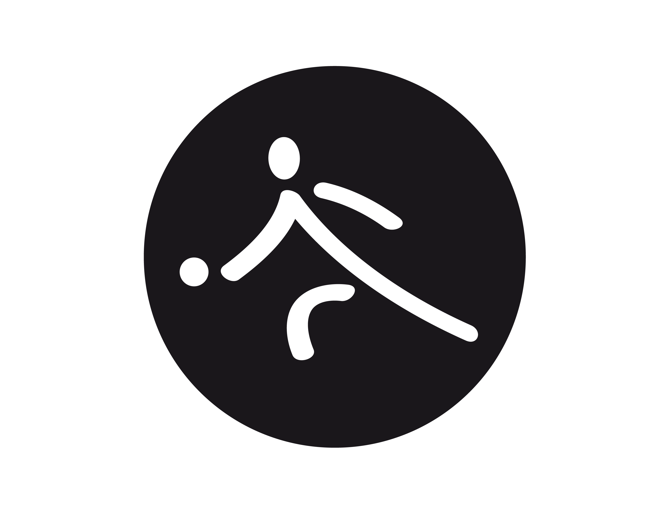

Special Olympics Pennsylvania

Bocce Score Sheet

Division ________ Court __________ Start Time ___________

Team (Name/County): ______________________ Ball Color _____________

Athletes Names: _____________________ and ______________________ Timeout ___

TALLY TOTAL POINTS:  1. When first points are scored circle the number of points.  2. When additional points are scored add that amount to the previous score and circle new total score. |  |  |  |  |  |  |  |  |  |  |  |  | FINAL SCORE | Head coach signature
POINTS | 1 | 2 | 3 | 4 | 5 | 6 | 7 | 8 | 9 | 10 | 11 | 12

Team (Name/County): ______________________ Ball Color _____________

Athletes Names: _____________________ and ______________________ Timeout ___

TALLY TOTAL POINTS:  1. When first points are scored circle the number of points.  2. When additional points are scored add that amount to the previous score and circle new total score. |  |  |  |  |  |  |  |  |  |  |  |  | FINAL SCORE | Head coach signature
POINTS | 1 | 2 | 3 | 4 | 5 | 6 | 7 | 8 | 9 | 10 | 11 | 12

Official’s validation _________________

- THIS FORM MUST BE RETURNED TO THE VENUE COORDINATOR IMMEDIATLEY FOLLOWING MATCH
- Game will end when one team reaches 12 points OR 30 minute time clock is reached.
- TIMEOUTS: One (1) allowed per game, cannot be used within last 5 minutes of the game. Credential coach may request timeout when all balls come to complete stop and their team is in possession of the ball. Timeout will last one minute, during this time coach may speak with the players.

