
Flag Football Individual Skills Competition

Catching: “Run & Catch”

- Purpose: To measure athlete’s ability to catch a football.

- Equipment: 5 footballs, measuring tape, field paint, cones, or numbered mats to mark catching spots and start/finish lines.

- Description: A starting line, finish line, quarterback box, and 5 catching spots should be marked/ placed on the field. The catching spots should be marked 1-5 (left to right).
- The quarterback box should be placed in between the starting and finish line.
- The quarterback box will be 4 yards X 4 yards.
- Catching spots are 1 yard X 1 yard.
- Catching Boxes 1 & 5 will be 5 yards from the quarterback box.
- Catching Boxes 2 & 4 will be 12 yards from the quarterback box.
- Catching Box 3 will be 20 yards from the quarterback box.
- The starting line should be placed on the left side of the quarterback and the finish line should be placed on the right side of the quarterback. Athletes will start to the left of the quarterback and finish on the right side of the quarterback.
- Each athlete will begin at the starting line. Once the official quarterback gives the signal, the athlete must run to each catching box (in numerical order), stopping to catch a pass at each spot. Once the ball is completely caught, the athlete drops the ball and goes to the next catching box. Once the last ball is caught, the athlete will sprint through the finish line. If a throw from the QB is deemed inaccurate, athletes will receive an additional throw from the same spot.

4. Scoring: Athletes will receive points for completing catches.
- 2 pts: for a complete catch (clearly caught with both hands)
- 0 pts: if athlete is unable to catch or touch a well-thrown pass.
- Athletes can gain a maximum of 10 points in this drill.
- Officials will be present to confirm point total.
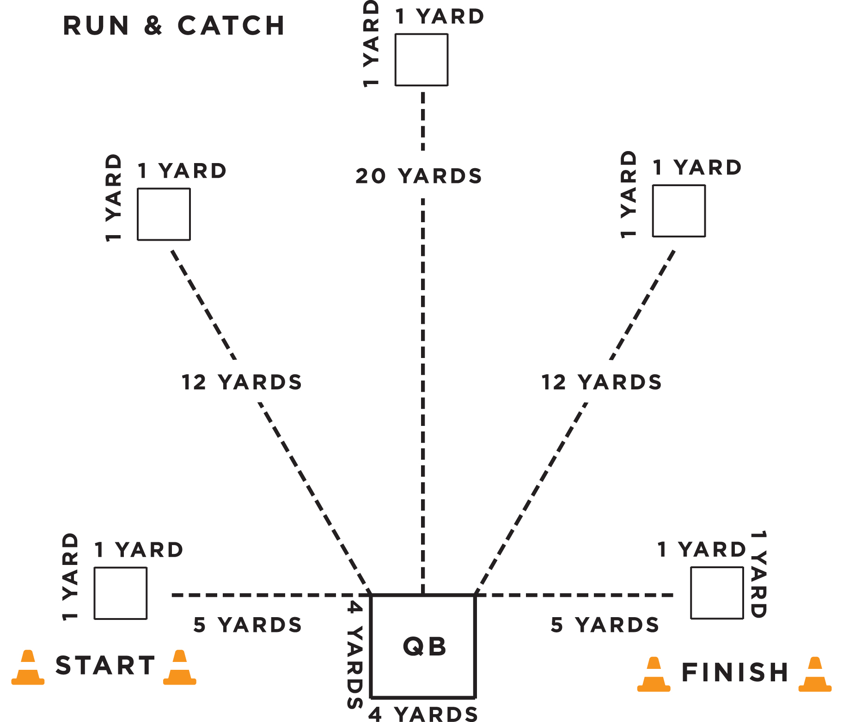

Throwing for Accuracy

- Purpose: To measure the athlete’s ability to throw a football accurately.

- Equipment: 5 footballs, measuring tape, field paint, cones, or numbered mats to mark catching spots and start/finish lines.

- Description: A starting line, finish line, quarterback box, and 5 catching boxes should be marked/ placed on the field. The catching boxes should be marked 1-5 (left to right).
- The quarterback box should be placed in between the starting and finish line.
- The quarterback box should be placed in between the starting and finish line.
- The quarterback box will be 4 yards X 4 yards.
- Catching spots are 1 yard X 1 yard.
- Catching Boxes 1 & 5 will be 5 yard from the quarterback box.
- Catching Boxes 2 & 4 will be 12 yards from the quarterback box.
- Catching Box 3 will be 20 yards from the quarterback box.
- The starting line should be placed on the left side of the quarterback and the finish line should be placed on the right side of the quarterback.
- The player being tested stands inside of the quarterback box. Five human targets/volunteers are placed in each catching spot. The athlete must throw to each target (in numerical order), gaining points for completed passes. The receiver must stay in the catching box. Scoring is based on accuracy of the throw not on the volunteer catching the pass.

4. Scoring: Athletes will receive points for completed passes.
- 2 pts: For an accurate & completed throw.
- 0 pts: Receiver is unable to catch or touch ball in targeted area. If the ball hits the ground prior to reaching the target, the throw will be recorded as a failed attempt.
- Athletes can gain a maximum of 10 points in this drill.
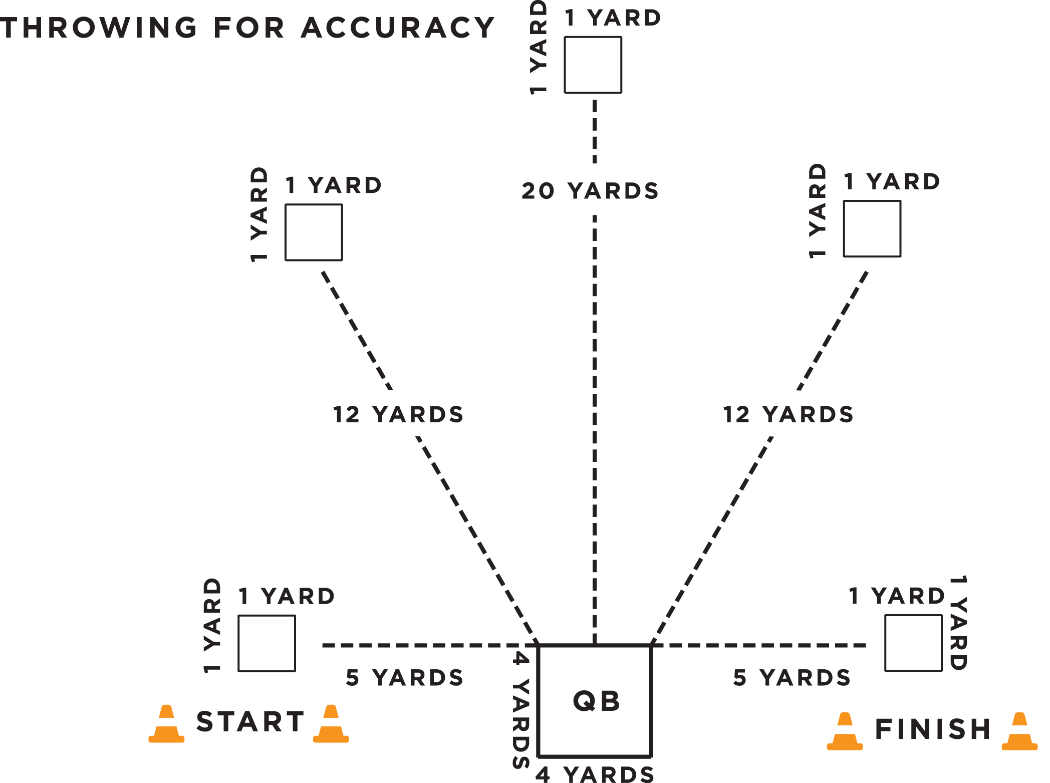

Throwing for Distance

- Purpose: To measure the athlete’s ability to throw a football for distance.

- Equipment: 3-5 footballs; measuring tape; field paint; cones

- Description: Athlete gets two attempts to throw football as far as possible. The goal line of a Special Olympics flag football field can be used as the starting line.

- Scoring: Athletes will receive a maximum of 5 points per throw.
- 1 pt: 0-10 yards
- 2 pt: 10-20 yards
- 3 pt: 20-30 yards
- 4 pts: 30-40 yards
- 5 pts: 40+ yards
- Athletes can gain a maximum of 10 points in this drill.

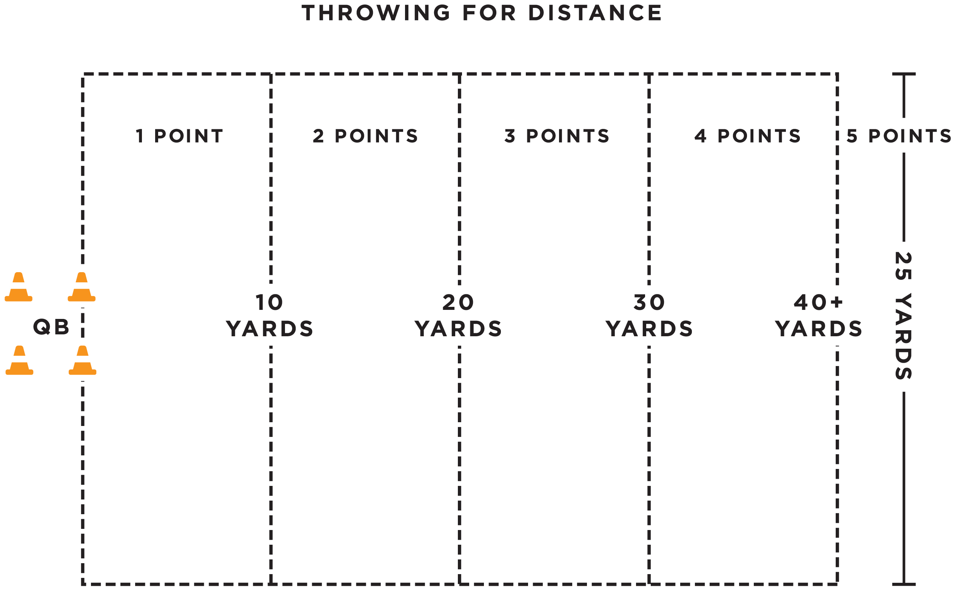

Agility & Speed: Hand-Off

- Purpose: To measure the athlete’s speed, agility and ability to receive a hand-off.

- Equipment: 3 footballs, eight cones, field paint, measuring tape, and stop watch

- Description: The ball is marked at the 20 yard line or 20 yards from the goal line. The quarterback will be position 20 yards from the goal line. Athlete begins 5 yards behind the quarterback and between the cones.
- The quarterback will give the signal and hand the ball off to the athlete.
- The clock will start on the quarterbacks signal.
- The athlete must maneuver around the four cones and sprints to the finish line/endzone between the cones and must maintain possession of the football.
- Each cone will be 1.25 yards apart
- A fumble at the exchange between the QB and the athlete would be a redo.
- If an athlete losses control of the ball, the clock continues to run. The athlete can recover the ball. However, if the ball goes outside the 3m lane, the athlete can either pick up the nearest back-up football or recover the errant football to continue the event.

4. Scoring: The athlete will receive two attempts. The athlete can receive a max of 5 points per attempt for a total of 10 points.
- The athlete will be timed from QB’s signal to when he/she crosses the finish line between the cones with possession of the football.
- One-second will be added for every missed cone.
- Conversion Chart will indicate score. Athlete can gain a maximum of 10 points.

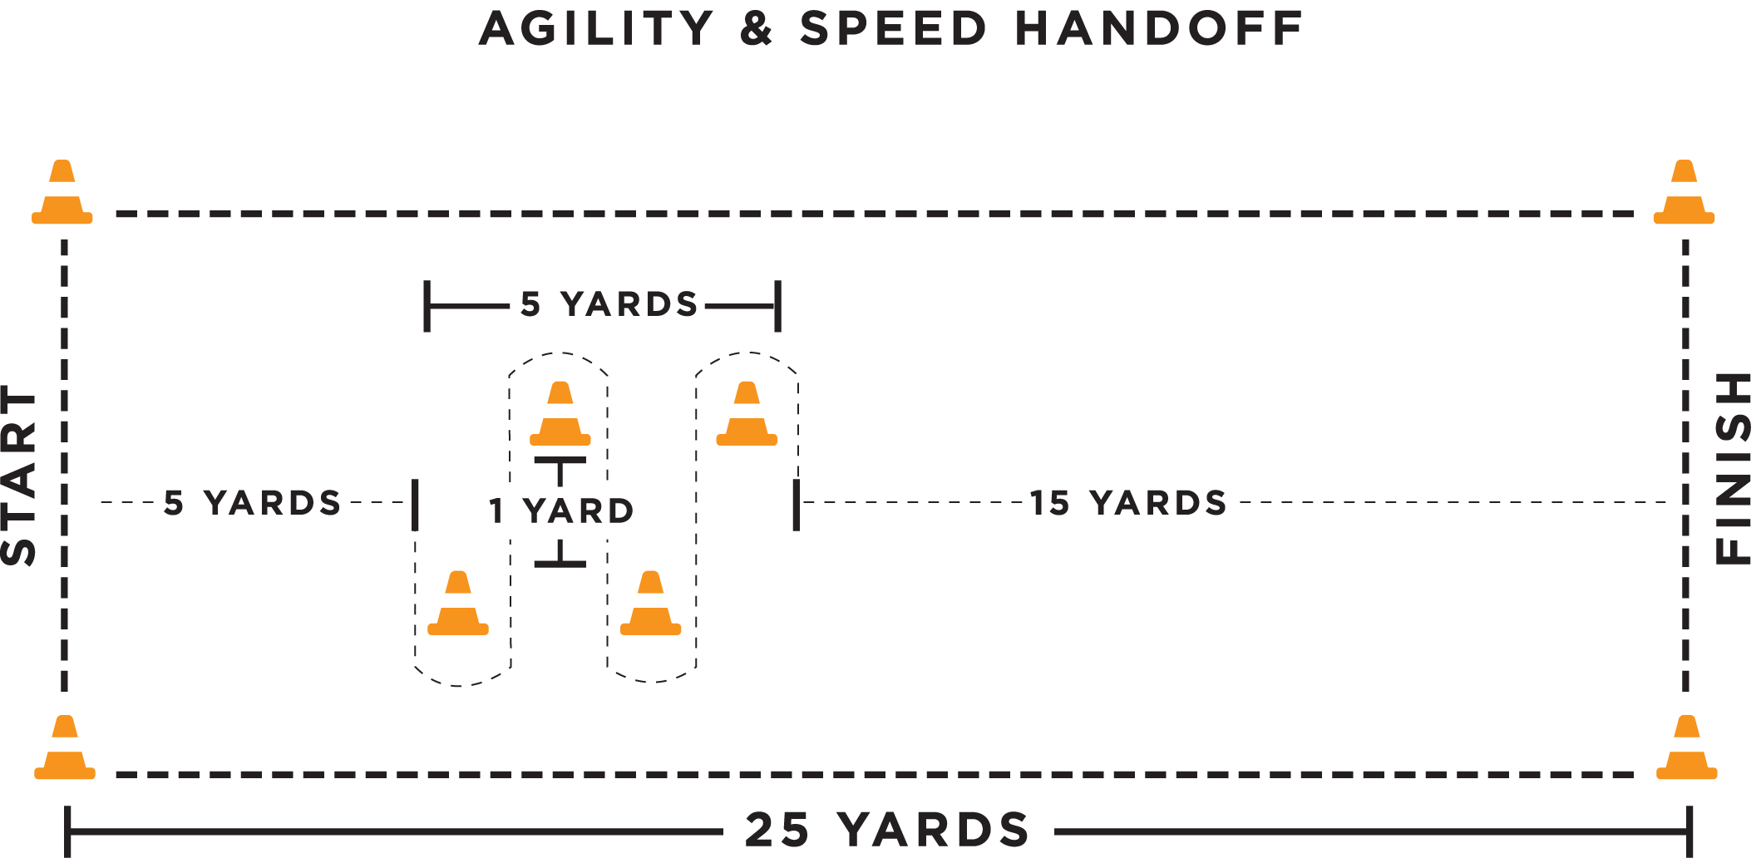

Agility & Speed: Hand-Off
Conversion Chart
Seconds Points
Under 7.5 seconds | 5
7.5-9 | 4
9.1-10.5 | 3
10.5-12.0 | 2
12.1 and over | 1

Flag Pulling

- Purpose: To measure the athlete’s ability to pull an opponent’s flag.

- Equipment: 5 footballs, four cones, 5 volunteers and measuring tape

- Description: The athlete stands in the middle of a 5 X 5 yard grid.
- Volunteers will one at a time jog through the grid with a football and attached flags. The athlete attempts to pull the volunteers flag before the volunteer leaves the grid. Volunteers will move straight through the box without attempting to elude athlete. Speed of volunteers will increase incrementally until the last volunteer is sprinting through.
- This is not a timed event. Each additional attempt will not start until the athlete has repositioned themselves at the center of the grid.

- Scoring: The athlete will receive 5 attempts
- The athlete will receive two points for successful flag pull.
- The athlete will receive one point for any unsuccessful flag pull in which either the flag or ball carrier was touched, but the flag did not come off.
- The athlete will receive zero points for any unsuccessful flag pull in which the flags or ball carrier are not touched at all.
- Once the jogging volunteer leaves the grids, he/she must reposition themselves in the center of the grid.
- Athletes can gain a maximum of 10 points in the drill.

FLAG PULLING
5yards

5 yards

Athlete
Volunteers

